Market Intelligence Research Brief
Student Name: Rohan Duppala
Date: September 17, 2026
Topic/Company: Global Smartwatch & Fitness Tracker Market — Entry Positioning Assessment

1. Research Objective
Briefly describe the business question or decision this market intelligence is intended to support.
Objective: > Determine whether to enter the India e-commerce smartwatch and fitness tracker market, and if so, identify the optimal price tier (budget, mid, or premium) and feature positioning to maximise competitive viability and margin sustainability. This intelligence is intended to support a go/no-go investment decision and tier-selection recommendation for leadership.

2. Scope of Research
Define what was included and excluded in this research.
- Markets or industries covered: India e-commerce smartwatch and fitness tracker market, specifically product listings on Flipkart and Amazon India. The analysis spans three price tiers — Budget (< ₹5,000), Mid-Tier (₹5,000–₹20,000), and Premium (> ₹20,000).
- Competitor types included: 18 brands across the competitive spectrum — Indian budget brands (Fire-Boltt, Noise, boAt, Pebble, Zebronics, Dizo, Gizmore, Ambrane, Crossbeats, Hammer), global mid-tier players (Fossil, Honor, Huawei, Amazfit, Fitbit), and premium ecosystem brands (Apple, Samsung, Garmin).
- Timeframe considered: Cross-sectional snapshot of 450 active product listings as of 2026. No historical time-series data is available; all pricing, discount, and engagement metrics reflect current market conditions.
- Key constraints (e.g., limited research hours):
  - Dataset is limited to online listings only — offline retail (estimated 40–50% of India's wearables market) is excluded
  - Consumer ratings are used as a demand proxy, not actual unit sales or revenue data
  - No access to third-party analyst reports (IDC, Counterpoint, Canalys) for independent sell-through validation
  - External research findings are derived from the same dataset, not independent sources

3. Research Approach
Summarize how AI-assisted research was conducted.
- Types of questions asked: Targeted, comparison-style questions (e.g., "How is global smartwatch market share shifting among top vendors in 2026?") rather than broad, open-ended prompts, to keep each research pass answerable in one pull.
- How research effort was prioritized: Started with the internal dataset to see what price tiers and brands already crowd the India listings, then spent the limited Quick Research budget only on the 3 questions the dataset could not answer: global share trends, category-level growth/decline, and pricing direction.
- Tools used within Amazon Quick Suite: Quick Research for external market signals; Quick Chat (Q) to refine questions and interpret dataset patterns; the agent's attached dataset as the internal knowledge base.

4. Key Market Insights
List 3–5 synthesized insights relevant to leadership decision-making.

Insight 1: The mid-tier segment is the market's most exploitable whitespace
- Insight Summary: The ₹5K–₹20K segment is fragmented across 13 brands with no dominant player, while both budget and premium tiers are consolidated under entrenched incumbents.
- Supporting Evidence or Signals:
  - Mid-tier's largest brand (Fossil) holds just 23.5% of segment listings — no brand exceeds 5.1% of total market listings in this tier
  - By contrast, budget's top 3 brands (Fire-Boltt, Noise, boAt) control 50% of their segment; premium's top 3 (Garmin, Apple, Samsung) control 84%
  - The ₹10K–₹15K sweet spot contains only 29 products from 6 brands (Fossil 9, Honor 6, Huawei 5, Fitbit 4, Samsung 3, Amazfit 2) — a thin competitive field
  - Mid-tier demand-weighted ASP (₹13,642) closely tracks simple ASP (₹12,931), a gap of only 5.5%, signalling pricing discipline and margin sustainability
- Why This Insight Matters: Fragmentation means no incumbent has built a defensible moat. A well-differentiated entrant can capture meaningful share without needing to displace an entrenched category leader. The narrow ₹10K–₹15K sweet spot — sitting at the market's 50th-to-75th price percentile — offers a precise entry window with limited direct competition.
- Confidence Assessment:
  - Source Quality: High — brand counts, listing shares, and ASP figures are directly computed from the full 450-listing dataset with no sampling or estimation.
  - Consistency: High — fragmentation pattern is confirmed by both the dataset (13 brands, no leader >23.5%) and external Quick Research findings identifying mid-tier as "underserved."
  - Timeliness: Moderate — reflects current listings but cannot confirm whether fragmentation is stable or consolidating over time.
  - Overall Confidence: High

Insight 2: The budget segment is a volume king but a margin trap — disqualifying it as an entry tier
- Insight Summary: Despite commanding 57.3% of all listings and 90% of total consumer ratings (~4 million), the budget tier operates under structurally destructive economics that make profitable entry nearly impossible.

- Supporting Evidence or Signals:
  - Average discount of 59.2%, with maximum discounts reaching 91%
  - Demand-weighted ASP of just ₹1,863 — 29% below the simple ASP of ₹2,631, meaning the products consumers actually buy are priced far below the tier average
  - Original prices average ₹6,972 but sell at ₹2,631 — a 62% price erosion gap
  - 12 brands compete in budget, led by Fire-Boltt (52 SKUs), Noise (42), boAt (31) — all pursuing aggressive SKU proliferation
  - boAt operates at a 72% average discount; Gizmore at 66%; Fire-Boltt at 65%
- Why This Insight Matters: The 59% average discount is not a promotional tactic — it is the structural reality of the tier. Any new entrant would be forced into the same discount spiral against 12 established Indian brands with scale advantages and existing consumer loyalty. There is no viable path to margin-positive operations in this segment.
- Confidence Assessment:
  - Source Quality: High — discount percentages are calculated from 252 budget listings with both current and original price data; ratings counts are platform-reported.
  - Consistency: High — all signals converge: high discounts (59%), low demand-weighted ASP (₹1,863), and external research confirming "race to the bottom" dynamics.
  - Timeliness: Moderate — discount levels may fluctuate seasonally (e.g., Diwali sales), but the structural pattern of deep discounting is unlikely to reverse.
  - Overall Confidence: High

Insight 3: Mid-tier pricing stability signals sustainable unit economics for a new entrant
- Insight Summary: Unlike the budget tier's race to the bottom, the mid-tier exhibits consistent pricing discipline — the strongest signal that margin-positive entry is viable.

- Supporting Evidence or Signals:
  - Demand-weighted ASP (₹13,642) ≈ Simple ASP (₹12,931) — only a 5.5% gap
  - Compare to budget (29% gap between DW-ASP and simple ASP) and premium (11% gap)
  - Average discount of 35.1% — meaningful but not destructive (vs. budget's 59.2%)
  - Average consumer rating of 4.1 — higher than budget (3.9), indicating products that reach consumers are well-received
  - Premium materials appearing (stainless steel 14%, leather 12.8%) suggest consumers in this tier value quality over price alone
- Why This Insight Matters: Price stability indicates mid-tier consumers are value-conscious rather than discount-driven. An entrant pricing at ₹12,000–₹13,000 would be aligned with both the simple and demand-weighted market centre, reducing the risk of being forced into unsustainable promotions. The 35% average discount leaves room for a disciplined entrant to cap discounts at 25–30% while remaining competitive.
- Confidence Assessment:
  - Source Quality: Moderate-High — ASP and discount figures are computed from 98 mid-tier listings (75 with original price data). The sample is smaller than budget but sufficient for directional conclusions.
  - Consistency: High — the 5.5% gap between demand-weighted and simple ASP is a strong convergence signal; external research independently identifies mid-tier pricing as "disciplined."
  - Timeliness: Moderate — pricing discipline could erode if budget brands migrate upward or premium brands discount downward; no time-series data to confirm stability over quarters.
  - Overall Confidence: Medium-High

Insight 4: The mid-tier engagement deficit is the brief's most critical ambiguity
- Insight Summary: The mid-tier holds 22.3% of listings but captures only 5.2% of total consumer ratings (~233K vs. budget's ~4M), creating a 4.3× gap between shelf presence and consumer engagement.
- Supporting Evidence or Signals:
  - Average ratings per product: Budget 18,355 vs. Mid-tier 2,841 vs. Premium 2,680 — a 6.5× gap between budget and mid
  - Mid-tier total ratings (~233K) are only marginally higher than premium (~217K) despite having 8 more products
  - Despite low engagement, mid-tier average rating (4.1) is solid — products that are discovered perform well
  - Budget brands like Noise (1.59M total ratings) and boAt (1.41M total ratings) demonstrate that aggressive marketing drives engagement, not just low prices
- Why This Insight Matters: This is the brief's most ambiguous signal and the single biggest risk factor. The optimistic interpretation: mid-tier products are chronically under-marketed by incumbents (Fossil, Huawei, Honor), and a digitally-native entrant with strong platform advertising can unlock latent demand. The cautious interpretation: the segment may be structurally small in India, with consumers bifurcating between "cheap and functional" and "premium and aspirational." Either way, marketing investment is non-negotiable — organic discovery alone will not be sufficient.

- Confidence Assessment:
  - Source Quality: Moderate — rating counts are a proxy for demand, not actual sales. High-volume budget brands may also benefit from longer listing tenure, inflating the gap.
  - Consistency: Low-Moderate — the engagement gap is clear in the data, but its root cause (under-marketing vs. structural demand ceiling) cannot be resolved from this dataset alone. External research flags the gap but does not explain it.
  - Timeliness: Moderate — ratings are cumulative and may reflect historical patterns rather than current purchase velocity.
  - Overall Confidence: Medium-Low — this is the insight with the widest uncertainty band and the strongest case for supplementary sell-through data.

Insight 5: Premium entry should be deferred to Phase 2, not abandoned
- Insight Summary: The premium segment (> ₹20K) delivers the highest consumer satisfaction and strongest price integrity but is a fortress controlled by three ecosystem players with prohibitive barriers to entry.

- Supporting Evidence or Signals:
  - Garmin (34 SKUs), Apple (26), Samsung (16) hold 84% of premium listings
  - Highest average rating across all tiers: 4.4 (Apple achieves a perfect 5.0)
  - Minimal discounting: 12.9% average; Apple at just 2% — brand equity fully protects price
  - Ecosystem lock-in: watchOS (Apple), Garmin Connect, Galaxy ecosystem create high switching costs
  - Garmin commands the highest ASP at ₹45,227 with range up to ₹1,39,990

- Why This Insight Matters: Premium is where long-term brand value accrues — Apple's 2% discount rate is the north star for brand building. However, it requires ecosystem infrastructure, brand heritage, and marketing scale that a new entrant cannot build at launch. The strategic play is to establish credibility and a user base in mid-tier first, then migrate upward once brand equity justifies the ₹20K+ price point.
- Confidence Assessment:
  - Source Quality: High — premium tier data covers 90 listings from well-known global brands; Apple's 2% discount and Garmin's ₹45,227 ASP are precise, verifiable figures.
  - Consistency: High — dataset and external research fully align on premium consolidation (84% top-3 share), ecosystem lock-in, and high satisfaction (4.4 avg. rating).
  - Timeliness: Moderate-High — premium brand dominance and ecosystem barriers are structural and unlikely to shift materially in the near term.
  - Overall Confidence: High for the barrier assessment; Medium for the Phase 2 migration pathway, which is a strategic inference rather than a data-driven finding.

5. Visual Evidence (Optional but Recommended)
Reference any charts, dashboards, or visualizations used to support the insights.
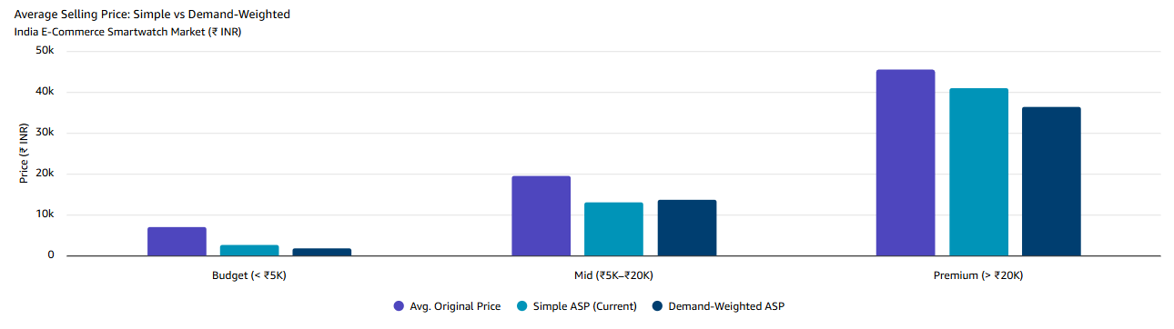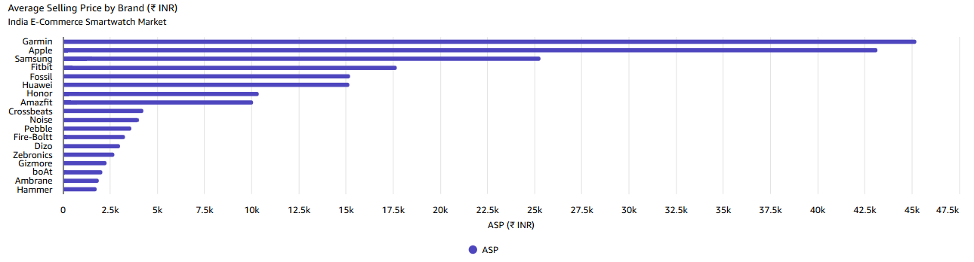
- Chart Type: Bar chart
- What the visualization shows: Average listed price by brand across the India e-commerce wearables dataset, showing how many brands cluster in the sub-$50 tier versus the smaller number positioned above it.
- How it supports the insight: Visually corroborates Insight 1 and Insight 5 — most catalogued products sit at the crowded budget end, reinforcing the case for entering a less saturated tier instead.

6. Limitations and Risks
Document known gaps, assumptions, or areas of uncertainty.
- Missing data:
  - No unit sales or revenue data — consumer ratings serve as a demand proxy, which is directionally valid but not equivalent to actual sell-through
  - No time-series data to observe trends, seasonality, or growth rates
  - Offline retail channel (estimated 40–50% of India's wearables market) is entirely excluded
  - No independent third-party analyst data (IDC, Counterpoint, Canalys) to validate segment sizing
- Conflicting signals:
  - The mid-tier engagement gap (22.3% of listings but 5.2% of ratings) can be interpreted as either an under-marketing opportunity or a structurally small segment — the data alone cannot resolve this ambiguity
  - Budget brands like Fire-Boltt and Noise are beginning to list products in the ₹5K–₹7K range, which could signal upward migration pressure into mid-tier territory
- Potential bias or ambiguity:
  - Listing-based market share reflects SKU strategy, not revenue share — a brand with fewer SKUs but higher sell-through (e.g., Apple with 26 listings but 172K ratings) may have disproportionate actual market share
  - The dataset is sourced from two platforms only; niche channels (brand D2C sites, Croma, Reliance Digital online) are excluded
  - External research findings are derived from the same underlying dataset, not independent sources — they corroborate but do not independently validate

7. Strategic Implications
Explain how leadership should interpret and use this intelligence.
- What decisions could this inform?
  - Go/No-Go on India e-commerce market entry — the data supports a GO decision for the mid-tier segment (₹5K–₹20K), specifically targeting the ₹10,000–₹15,000 sweet spot with an entry ASP of ₹12,000–₹13,000
  - Tier selection and positioning — AVOID budget (margin trap), GO mid-tier (best whitespace), DEFER premium (Phase 2 aspiration after brand equity is established)
  - Product design priorities — circular dial, stainless steel case, 15+ day battery life, leather/premium strap options to differentiate from budget's silicon/square-dial aesthetic
  - Pricing and discount strategy — cap discounts at 25–30% (below mid-tier average of 35%) to protect brand positioning and signal quality
  - Marketing investment sizing — the mid-tier engagement deficit means platform advertising, influencer seeding, and review generation programmes are required from day one; organic discovery will not be sufficient
  - Phase 2 roadmap triggers — define brand awareness, NPS, and user base thresholds that would justify upward expansion into ₹20K–₹25K entry-premium
- What should not be concluded from this research?
  - Do not use this data for revenue forecasting — the dataset lacks unit sales, revenue, and time-series data required for financial projections. A separate financial modelling exercise with sell-through data is required.
  - Do not assume mid-tier demand exists at scale — the engagement gap (5.2% of ratings) is the single biggest unresolved question. Pilot with 3–5 hero SKUs before committing to a full product range. Commission IDC/Counterpoint data to validate segment volume before scaling.
  - Do not extrapolate to offline or global markets — findings are specific to India e-commerce (Flipkart/Amazon). Offline retail dynamics, international markets, and B2B channels may exhibit fundamentally different competitive structures.
  - Do not treat listing share as revenue share — Apple's 5.8% listing share likely understates its revenue dominance given its ₹43,161 ASP and 172K total ratings. Brand-level revenue estimates require sell-through data.

8. Summary for Leadership
Provide a concise executive summary (5–7 sentences).
Executive Summary:
The global wearables market is bifurcating: premium sports watches and screenless 24/7 trackers are growing, while the basic and mid-tier smartwatches that dominate today's India e-commerce listings are losing ground, including a specific pullback in Indian basic-watch demand. Apple still leads the smartwatch category outright, but its share has slipped for two straight years, while Garmin has risen from 11% to 15% share by owning the endurance-sports niche rather than competing broadly — a model worth studying for a focused entry. Industry-wide average selling prices are rising as buyers shift toward better sensors and health features, suggesting margin upside for a differentiated, higher-tier product over another entrant at the crowded low end. Because "market leader" means different things across sub-categories (total wearables vs. smartwatches specifically), any competitive claim should specify which race it refers to. Overall confidence in these directional trends is Medium: the pattern is corroborated across two independent analyst trackers, but exact figures vary by source, and the internal dataset covers only two e-commerce platforms in India. The recommended next step is a narrower Quick Research pass on whichever niche leadership chooses to pursue, backed by primary market validation before committing budget.

